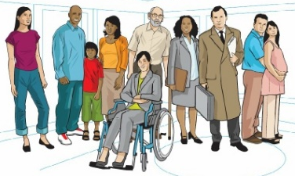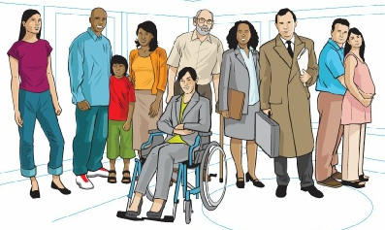
Alnwick Medical Group - Patient Participation Group
c/o Lower Building, Infirmary Close, Alnwick, Northumberland NE66 2NL
Telephone messages via: 01665 656000
“Give me the ability to, change what I can, recognise what I can’t and wisdom to know the difference.”

Minutes of the meeting of the Alnwick Medical Group Patient Participation Group
held at Alnwick Medical Group 23rd August 2023 13:30-15:00

Present Dr DM (Chairman)
Dr Adam Henry (GP Partner)
JC
SW
PS
TD
SE
PR
DF
Karen Armstrong (Wellbeing Coordinator)
Linda Harvey (Social Prescriber)
Stephanie Evans (Secretary)

Apologies SW
JPC
GP
BW
DD

Welcome
DM started the meeting at 1330, each person gave the room a brief introduction.

Matters arising from previous minutes.
Northern Guilds Psychotherapy Service – Steph passed on update to the group that this has temporarily had to be put on hold by the person who was due to come in due to health reasons.
New Practice Manager – Dr Henry gave update that the new practice manager Paula Breen is due to start around the beginning of October.

Klinik – Dr Henry gave an update that other systems are now being looked at, and the decision on which system is used will be made by the PCN. One of the other options is called Anima and will be discussed at the Partners meeting on the 4th Sept. DM explained the benefits of surgeries using the same system such as ease of transfer of medical records when patients move and a single system will easier for HCP if they move surgery or for locums who move frequently.

PR has been in touch with Klinik and had a meeting with a sales rep. His opinion is that the Klinik seems to be more intuitive than the current system and he believes that from the point of view of the practice, it will save time and therefore increase capacity. Overall PR felt that Klinik was promising. Steph will email PRs thoughts to Kim Hall.

SE left the meeting at 13:40

Care plans – DF had spoken with Karen Wood, but DF is not happy with the outcome of the care plans. He feels that nothing has changed, and the information will be too much for the average patient. PR asked if there was a commitment to care plan progress and if it was for all long term conditions. Dr Henry discussed this and agreed that care plans need to be meaningful for both patients and HCP. SW shared her experience of a recent review in which she had no problems.
Karen will look at getting confirmation of what LTCs have a care plan and what information is included.

Well Pharmacy – Dr Henry provided an update that Well do not currently have a manager or a full time pharmacist.

The Primary Care Network (PCN)
Karen explained to the group about how the PCN was introduced in 2019 to group surgeries together so that they could share and provide a greater number of services, that otherwise wouldn't be available to them. Our PCN covers an area from Morpeth to Berwick and focuses on non clinical support such as physio, pharmacy, health and wellbeing and cancer support.

Linda explained about her role as a social prescriber and how she supports people with social issues such as housing and financial issues. Linda will see people up for up to 12 contacts and can refer people on to more specific services. People can also be referred back in if they need further support.

Karen works to raise awareness of the PCN by training all staff of what they can offer, patients can be referred in by the reception team. Karen also attends 'Walking and Talking' every Tuesday with Mind and Sole and The Alnwick Garden Elderberries Tea and Tech Group once a month.

Linda explained a Well Up North app is currently being trialled which will allow patients to self-refer. JC raised the point that this should be tested by patients as they are people the who will be using the app and also that it should not have too many pictures as this will drain people's data. Linda agreed that this was a good idea and she will raise it with her manager.

PS asked if the Social Prescribers help people who are in care homes. Karen and Linda have not yet had any request from people living in care homes but have supported families who have needed help with assessments and funding for family members who need to move into a care home.

JC asked Linda if she does much outreach work, Linda explained that she works one day from AMG and one day from the Embleton Branch, then works in the community and from home the rest of the week. This allows her to meet with patients in an environment that they feel most comfortable.

Signs for new entrance
Dr Henry passed on an update that there are plans for the old door to be blocked off as it will be turned into a workable room. A frosted Alnwick Medical Group sign has been ordered for the new door.

Bushes and Greenery
TD brought up that she feels that the bushes are too big and not cut far enough back. The bushes are currently maintained by Northumbria NHS Trust.
Steph had an update on the broken slab that a quote had been found to fix it, but it was currently on hold due to a query with Northumbria NHS Trust. It was agreed by the group that the area can look untidy and tree roots under paving slabs are a trip hazard. Steph will speak Danielle about any possible improvements to the site.

Dr Henry left the meeting at 14:30

Any Other Business

Steph raised that PPG minutes should be included on the AMG website and would people be happy with this if names were shortened to initials for privacy reasons. The group agreed this would be ok.

PS had a copy of Longhoughton Parish Newsletter which shows the councils wishes for services to provided in the community centre. JC mentioned that there had been meetings regarding this in the village.
Steph will email Dr Syers to see if there has been any update.

It was discussed how we could possibly raise awareness of the PPG for younger people. Karen already regularly advertises on social media. Linda has offered to suggest the PPG to any patients who are looking for community groups and to include mention of it on The Scoop e-magazine. New notice boards have been ordered, once these are up, posters can again be put back up.

Next Meeting
Around start of October, exact date to be confirmed.

Item for next Agenda
AMG Website and IT support

