Farming Community FREE Health Check at
THE GLENDALE SHOW
Date: Monday 28th Aug 2023
YOUR North Northumberland Primary Care Network "Well Up North"
9 GP Practices working together to improve healthcare outcomes and reduce health inequalities for our patients.
Alnwick Medical Group Greystoke Surgery
Belford Medical Practice Union Brae and Norham Practice
Coquet Medical Group Well Close Medical Group
Felton Surgery Wooler Health
Gas House Lane Surgery
What we can offer on the day
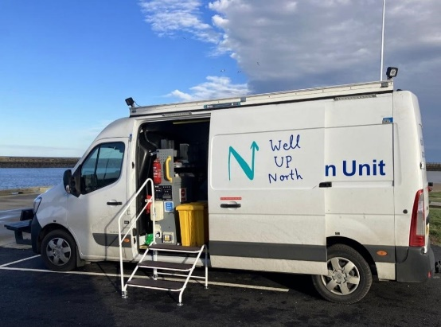
- Blood Pressure Check
- HBa1c Diabetes Blood Check
- Cholesterol check
- Muscular Skeletal pain check
- Mental Health Information
- Health and Wellbeing Coach
- Health Inequalities questionnaire
- Health Information
- Onward referral if required

ALL the above are optional

Well Up North staff at the show:

- GP
- Nurse
- Physiotherapist
- Health Care Assistant
- Health & Wellbeing Coach
- Health Inequalities Coordinator
Please come and see us on the day if you want a chat about your health, have any health concerns, or want to have a BP, Diabetes or Cholesterol check.

Confidential area for any 1-2-1

