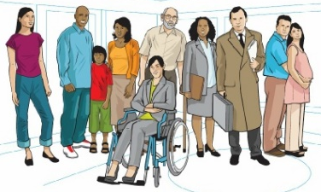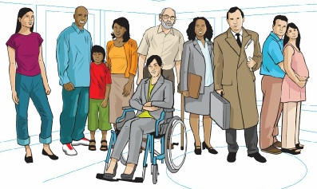
Alnwick Medical Group - Patient Participation Group
c/o Lower Building, Infirmary Close, Alnwick, Northumberland NE66 2NL
Telephone messages via: 01665 656000
“Give me the ability to, change what I can, recognise what I can’t and wisdom to know the difference.”

Minutes of the meeting of the Alnwick Medical Group Patient Participation Group held at Alnwick Medical Group 04th October 2023 14:00-15:30

Present Dr DM (Chairman)
EG
GP
JJS
PR
DF
SB
FK
TD
PS
Danielle Graham (Patient Liaison Co-ordinator
Karen Armstrong (Wellbeing Coordinator)
Linda Harvey (Social Prescriber)
Stephanie Evans (Secretary)

Apologies VH
JH
SE
JPC
CA
GF
DD

Welcome
DM started the meeting at 1400, each person gave the room a brief introduction.

Matters arising from previous minutes.
New Practice Manager – Steph gave an update that the new practice manager Paula Breen is due to start her new post 09th October.

New booking system – Steph gave update from Kim Hall that it is looking likely that the new booking system will be called Anima Anima | For patients (animahealth.com). This is system is similar in features to Klinik. AMG are currently waiting on a decision from the PCN as to which system will be implemented and it is hoped it will be up and running in the next couple of months.
Steph will see if it is possible to get an online demo for the next meeting.

Care plans – Karen has spoken to Natalie, one of the practice nurses who has agreed to discuss in the PN meeting. Karen Wood Nurse Manager has discussed care plans with DF, however DF is not satisfied, he spoke of how the 'Year of the Care plan' should involve a follow up for all patients to discuss how they can improve their health. Karen explained this may not be possible due to lack of facilities.
JJS spoke of person-centred care, being proactive and improving communication for patients, she will feedback concerns to CNTW.
Steph will ask if Karen Wood can attend next meeting to discuss care plans and show a care plan template.

Garden Maintenance – Danielle confirmed that bushes on the site had all recently been trimmed.
Danielle informed the group that someone is coming out to provide a quote for fixing the broken paving slab, and a tree surgeon will be coming to assess the tree roots.
GP raised the query of whether a bin will be provided outside. Danielle confirmed that a bin won't be provided outside, however there are plenty bins available inside for patients to use. It was agreed that the area can look shabby due to litter.
Danielle will see if it is possible for the cleaners to pick up rubbish outside.

Longhoughton – Longhoughton surgery has been fully closed down. SB is a trustee of the Community Centre, he confirmed there is suitable space available and that Adrian Hinchcliffe had been part of a partners meeting to discuss services which could be run from the Community Centre. It was agreed that as the village bus service is being cut, services were needed more than ever.
A clinic has been set up deliver flu jabs from the community centre.
Await further updates from Dr Syers.

IT Support – Danielle confirmed that there is an IT administrator employed by AMG but the website is run by an outside contractor. JC and EG both agreed that AMG should have better access to their own website. It was agreed that the website could be better and members had noted various discrepancies including one on the front page.
It was agreed that any future changes to AMG IT should be trialled by PPG members.
Danielle and Karen have a meeting with Paula in the next couple of weeks in which they can discuss the website.

CNTW
JJS discussed with the group her role as a Carer Governor for older people's services for Cumbria, Northumberland, Tyne and Wear (CNTW) NHS Trust.
JJS talked about how her role is to hold the Board to account and represent members of the public. JJS also showed the group a copy of the Carers Promise and talked about the NHS involvement bank.
JJS agreed she would email out some further information about the trust and offered to speak to any members who wish to become more involved with the involvement bank.

Any Other Business
GP mentioned her recent experience of asking for a mole check during a Well Woman clinic where she was advised to send in photos by e-consult. This started a discussion on people's experiences of triaging and getting appointments. Danielle and Karen explained how the current triaging system works and how it is hoped that new system will bring improved access for patients.
Steph will look at arranging an appt for GP.

PS talked about her recent experiences of receiving the wrong medication and asked where this fall down happens. Other members discussed their own experiences. Karen explained about how repeat dispensing works with the group.

